Power BI:

Power BI Free enables you to connect to 70+ data sources, publish to the web, and export to excel. There are some limitations to the free version. For example, you can’t do peer-to-peer sharing and you can’t create App workspaces. However, the free version is great if you are doing your own analysis and don’t need to distribute the analysis to other end users. You also have connectivity options such as Direct Query, live connection, and the use of the gateway. The same visualizations that are available in Power BI Pro are available in Power BI Free.

Power BI PRO:

The biggest difference between Free and Pro is that with Pro you can share your data, reports, and dashboards with other users who also have a Power BI Pro license. You can also create App workspaces. Both Power BI Free and Pro have a 10 GB per Pro user data storage limit. Here is a screenshot from [Microsoft’s Power BI website](https://docs.microsoft.com/en-us/power-bi/service-free-vs-pro) that summarizes the difference.

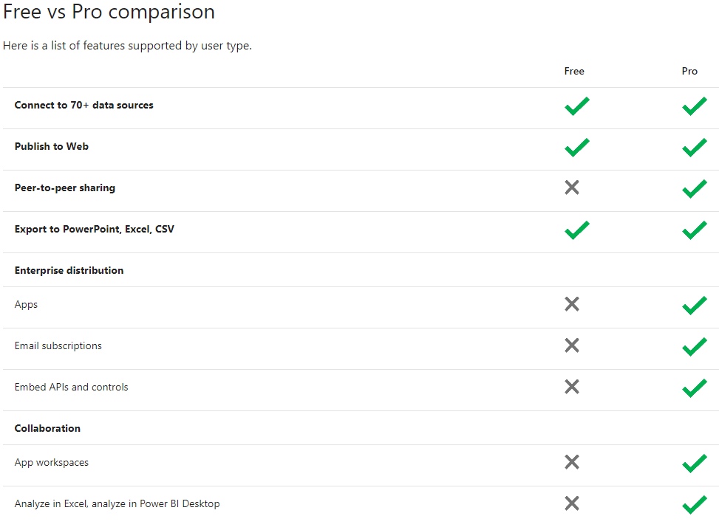

### Power BI Premium:

Power BI Premium is an on-premise deployment and distribution of Power BI reports using the Power BI Report Server. This allows you to maintain reports on-premise and move to the cloud when your organization is ready.

PRICING

|  |  |  |
| --- | --- | --- |
| POWER BI DESKTOP  **FREE** **9.99**  rrMonthly price per | POWER BI PRO  **$9.99** | POWER BI PREMIUM  **$4,995** |

Report view

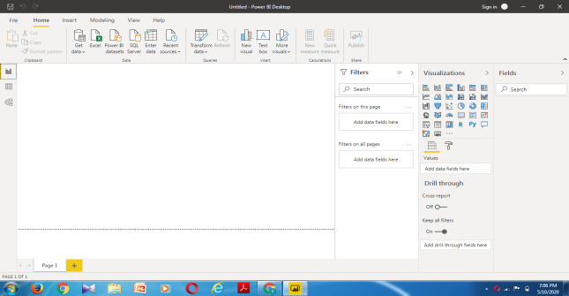

Data view

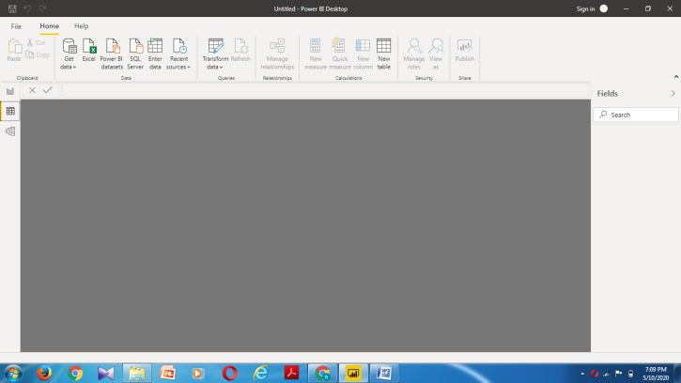

Model view

